In here I will put notes on things that broke and how to fix them as I followed the playlist myself in Visual Studio 2015.

Video 2 Notes:
GITHUB: f62e1c0
1- When you pull/checkout and open Visual Studio, if you're running the latest version of Visual Studio it may switch your platform to x64. Be sure you switch back to x86 as shown here:
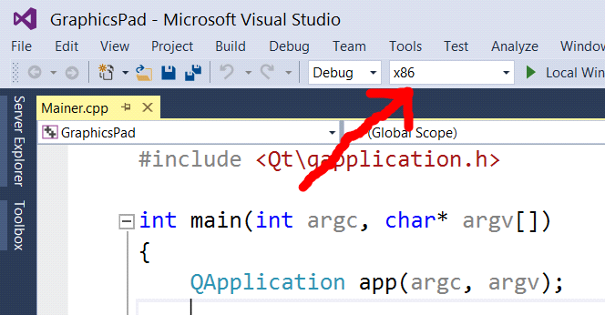
2- Visual Studio 2015 requires the mxvcp100d.dll and msvcr100d.dll files alongside the exe. I did not include them in the video because I was using an older version of Visual Studio but I have added them here.
